**Study about the mental health of the employees in the IT Industry while engaging in remote working**

M.N.M.Yusry, G.Arunath

*Department of Software Engineering, British College of Applied Studies, Kandy, Sri Lanka*

*MSc in Computer Science,BEng(Hons) Electrical &Electronics,MCP,MCTS,MCSA,* *Head-School of Computing, British College of Applied Studies, Kandy, Sri Lanka*

[arun@bcas.lk](mailto:arun@bcas.lk), [yusryy663@gmail.com](mailto:yusryy663@gmail.com)

1. **Introduction**

The physical, mental, and productivity of remote employees can all be improved by having a better understanding of work-life balance. Many staff have been working from home, frequently without proper training and resources, as a result of physical distancing restrictions related to the COVID-19 pandemic. These modifications have had a negative impact on the mental health, increased stress, and decreased motivation of many employees, who have also reported lower work productivity. Employers struggling with the difficulties of working from home may find that mindfulness is a helpful strategy. Being mindful may be especially advantageous because it can increase workers' concentration on work-related tasks and, as a result, their performance. This paper provides simple explanations about the mental health of the employees in the IT industry while engaged in remote working.

The main aim of this research is to find out whether the employees are really motivated or not while engaged in remote working.

1. **Methodology**

This paper uses both primary and secondary research methods for finding facts. Studies about the mental health of the employees used in this research was gathered from similar articles published on the internet and also information were gathered by creating a questionnaire via google forms for the employees in the IT industry. The respondents for this study were the employees of the IT companies in the Kandy district. Then finding out whether the employees are really motivated or not while engaged in remote working. And finding out about the work life balance of the employees who are engaged in remote working.

In order to understand about the employees, the responses for the questionnaires were given by the employees in the IT companies and it was collected and evaluated to find out about the mental health of the employees. The questionnaires were provided using google forms. Analysis of the feedbacks were done using Microsoft Excel. 99 employees responded to the questionnaire. To conduct an effective methodology the “Saunders’ Research Onion” was applied

1. **Results**

In 2020, conventional working practices have been completely eradicated. Zoom calls and Slack group chats have taken the place of crowded offices, and people's attitudes regarding working from home have entirely changed. Spare rooms are now furnished with workstations, monitors, and keyboards.

The advantages and disadvantages of working from home have been extensively discussed and published, particularly those relating to workplace performance, mental health, and productivity. To further investigate this, this research was conducted to study about the mental health of the employees while engaging in remote working. The findings of this study will be shared and discussed in this paper. To examine how people mental health have been affected differently and how perspectives may differ.

**Age and Gender of the employees.**

Figure 1 age limit of the employees

Figure 2 gender of the employees

The above give column charts are the analysis of the age and gender of the employees. According to the chart 74.7% of the employees are between the age of 18 – 29 and 22.2% of the employees are between the age of 30 – 39. And only a 3% of them are in between of the age of 40 – 49. Also, 78.8% of the employees are male and 22.2% of them are female. It shows that there are more male employees working in the industry than female employees.

**Rating of the physical health and mental health of the employees.**

Figure 3 employees physical health

Figure 4 employees mental health

The above given charts are the ratings of the physical and mental health of the employees while engaged in remote working. 51.5% of the employees have rated ‘Good’ saying that they are good with their physical health and 41.4% of the employees are have rated ‘Excellent’ saying that their physical health is perfectly alright. And only 7.1% of the employees have rated ‘Fair’. So, with this rating we can say that most of the employees have a good physical health while engaged in remote working.

As you can see the mental health chart, 59.6% of the employees have rated ‘Good’ and 26.3% have rated ‘Excellent’ saying that they have a good mental health while engaged in remote working. And 14.1% have voted ‘fair’. So, according to these responses we can say that most of the employees have a good mental health while engaged in remote working.

**Any problems with the daily life due to remote working.**

Figure 5 problems due to remote working

The above chart shows whether the employees had any problems with their daily life because of remote working. 74.7% of the employees have selected ‘No’ saying that they don’t have any problems with their daily life due to remote working. 21.2% of the employees have selected ‘Maybe’ saying that they might or might not have had problems with their daily life due to remote working. And 4% of the employees have selected ‘Yes’ saying that they had problems with their daily life due to remote working. With this we can say that most of the employees don’t face any problems in their daily life and only a very few employees face problems with their daily life due to remote working.

**How often has mental health affected the employee’s ability to get work done?**

Figure 6 mental health affected the employee’s ability to get work done

As you can see the above chart, 27.3% of the employees have selected ‘Not at all’ saying that their mental health has not affected their ability to get work done. 40.4% of the employees have selected ‘Not so often’ saying that their mental health hasn’t affected them. And 27.3% of the employees have selected ‘Somewhat often’ saying that sometimes mental health affects them to get their work done.

**Unmotivated because of remote working.**

Figure 7 unmotivated because of remote working.

In the above chart 82.8% the employees say that they are not unmotivated because of remote working. And 12.1% of the employees say that they might or might not be unmotivated because of remote working. And only 5.1% of the employees have said that they are unmotivated because of remote working. And by looking at the above chart we can say that most of the employees are not unmotivated because of remote working.

**How often has your mental health affected your relationships with your family while engaging in remote working?**

Figure 8 mental health and relationship with the family

The above chart shows that 30.3% of the employees have selected ‘Not at all’ saying that their mental health has not affected their relationship with their family while engaged in remote working. 41.4% of the employees have selected ‘Not so often’ saying that their mental health hasn’t affected their relationship with their family while engaged in remote working. And 25.3% of the employees have selected ‘Somewhat often’ saying that sometimes mental health affects them with the relationship with their family.

**Remote work make you feel good/positive about yourself.**

Figure 9 remote working makes you feel good/positive

In the above chart 59.6% the employees say that they feel good/positive about themselves while engaged in remote working. And 38.4% of the employees say that they might or might not feel good/positive about themselves while engaged in remote working. And only 2% of the employees have said that they don’t feel good/positive about themselves while engaged in remote working. And by looking at the above chart we can say that most of the employees feel good/positive about themselves while engaged in remote working.

**Have you ever liked to change your job because of stress caused by remote working?**

Figure 10 change your job because of remote working

In the above chart 87.9% the employees have said that they never liked to change their job because of stress caused by remote working. And 9% of the employees say that they might or might not like to change their job because of stress caused by remote working. And only 3% of the employees have said that they liked to change their job because of stress caused by remote working. And by looking at the above chart we can say that most of the employees never liked to change their job because of stress caused by remote working.

**Are you concerned that a lack of social interaction among colleagues will have a long-term negative impact on some workers’ mental health?**

Figure 11 concerned that a lack of social interaction among colleagues will have a long-term negative impact on some workers’ mental health

27.3% of the employees have agreed that they are concerned that a lack of social interaction among colleagues will have a long-term negative impact on some workers’ mental health. And 31.3% of the employees say that they disagree with this and 37.4% say that they are neutral with this. And only 4% of the employees strongly disagreed this. So, we say that some of the employees are concerned with this and some are neutral with this statement.

**Do you prefer working remotely or in person?**

Figure 12 do you prefer working remotely or in person?

As you can see the above chart 53.5% of the employees prefer working in person and 46.5% of the employees prefer working remotely. So, we can say that most of the employees are willing to in person as well as remotely.

**Do you expect a decrease in work life if engaged in remote working?**

Figure 13 Do you expect a decrease in work life if engaged in remote working

In the above chart 75.8% the employees have said that they do not expect a decrease in work life if engaged in remote working. And 18.2% of the employees say that they might or might not expect a decrease in work life if engaged in remote working. And only 6% of the employees have said that they expect a decrease in work life if engaged in remote working. And by looking at the above chart we can say that most of the employees do not expect a decrease in work life if engaged in remote working.

**Which of the following reasons play a role in wanting to leave your job because of remote working (select all that apply)?**

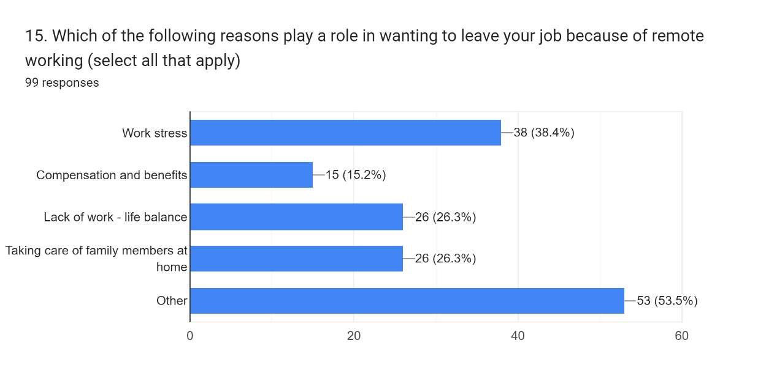

Figure 14 reasons wanting to leave your job because of remote working

In the above graph 38.4% of the employees have said that work stress is a reason to leave their job because of remote working. And 15.2% of the employees have said that their reason to leave the job because of compensation and benefits. 26.3% of the employees have said that lack of work – life balance and taking care of family members at home are the reasons for them to leave their job because of remote working. And 53.5% of the employees have said that apart from the mentioned reasons they have other reasons to leave their job because of remote working.

As you can see work stress is one of the important reasons for the employees wanting to leave their job. Lack of work – life balance and taking care of their family members is also an important reason for the employees to leave their job.

**Do you think that your mental health has improved or declined whilst working remotely?**

Figure 15mental health has improved or declined whilst remotely

In the above chart 67.7% of the employees have said that their mental health hasn’t improved or declined because of remote working. And 30.3% of the employees have said that their mental health has improved because of remote working. And only 2% have said that their mental health has declined because of remote working. So, we can say that mental health has improved and remained the same among the employees whilst working remotely.

**Do you think that conducting virtual workshops and wellness classes will help remote workers to be motivated?**

Figure 16 conducting virtual workshops and wellness class will help remote workers to be motivated

In the above chart 52.5% of the employees have said that conducting virtual workshops and wellness classes will help remote workers to be motivated. And 45.5% of the employees have said that may be conducting virtual workshops and wellness classes will help remote workers to be motivated. And only 2% have said that conducting virtual workshops and wellness classes will not help remote workers to be motivated. So, we can say that conducting virtual workshops and wellness classes will be an effective approach in helping remote workers to be motivated

**In a scale of 1 – 10 how would you rate your experience as a remote worker**

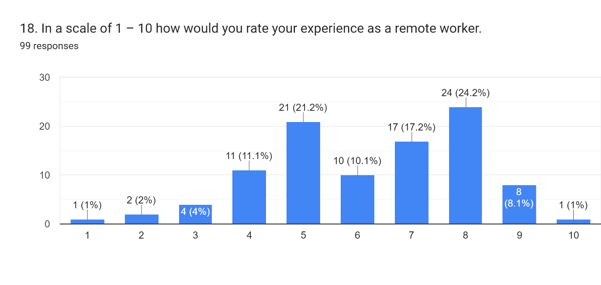

Figure 17 rating the experience as a remote worker

In the above given graph, you can see the ratings given by the remote working employees in the IT industry.

1. **Conclusion**

From this study we have found that 90% of the employees have enjoyed and had a positive experience whilst working remotely. And 90% of the employee’s mental health has generally improved as a result of working from home. While 10% of the employees certainly suffer with the loneliness and disconnect that come with working from home, others really benefit from doing so because it frees them up to spend more time at home recharging and concentrating on their work rather than going or working in a crowded/busy office environment.

The overall view seems to be that working from home has increased employee’s mental health, and some employees kept it about remained the same. And a very few employees did notice a decline in their mental health, but overall, the responses tended to be positive.

# References

Burton-Hughes, L., 2020. How Do Employees Feel About Home Working? Challenges and Benefits of Working From Home.

Education, W. S. o., 2021. An Exploration of Work-Life Wellness and Remote Work During and Beyond COVID-19. Volume 20.

Horizons, B., 2021. Mindfulness and the challenges of working from home in times of crisis. 64(2), pp. 189-197.

nsc, A. p. f., 2020. Survey shows many remote workers concerned about their mental health. *Family Safety and Health.*

Westfall, C., 2020. Mental Health And Remote Work.